**Conn QC measurements**

* **Raw data**

Check manually the structural and functional data

Check for artifacts (ghosting, aliasing, spatial distortions, signal dropouts).

Exclusion Criteria: Subjects with uncorrectable artifacts ,Incorrect orientation

Examples of special artifacts in raw data (Morfini et al,2023)

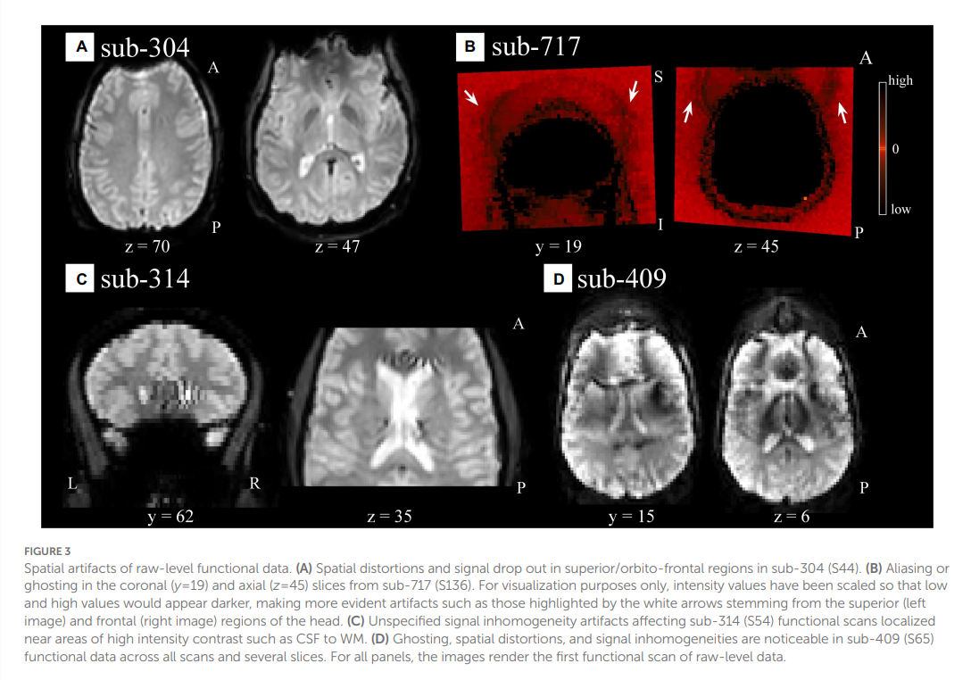

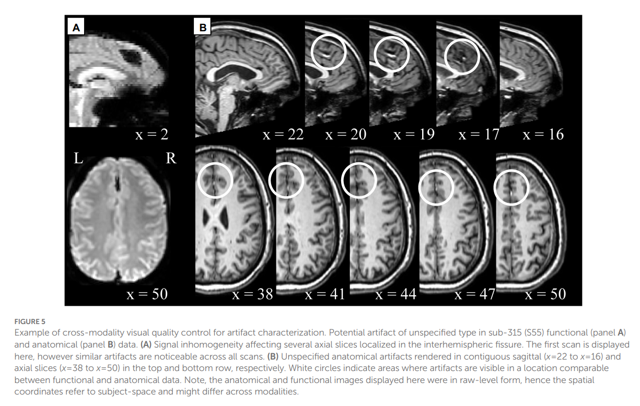

* **Preprocessed**

Identify preprocessing failures or extreme outliers.

Check QC-Norm of structural data, for finding different subject you can get montage in one slid from structural tools.(MNI boundaries represent the 25% boundaries of where the gray matter should be)

Check QC-Norm of functional data and overlay of structural and functional data from functional tools, visit montage for defending inconsistent subjects.

Example of incongruous subjects show in montages (Morfini et al,2023)

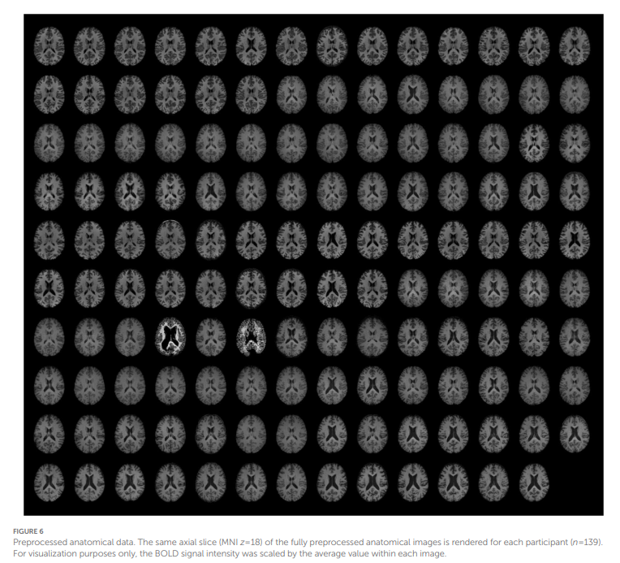

**1st level covariates**

In this level we have 3 measures:

1. Realignment (actual subject movement paraments across time representing how the subjects moved within the scanners )
2. QA- time series (First signal display global signal changes from one scan to other, second one show the frame way displacement (FD) , which is motions between scans acquisition )
3. Scrubbing (protentional outliners to time series)

**2nd level covariates**

After prepossessing CONN toolbox calculate automated QC measures such as:

QC-Valid scans

QC-Invalid scans

QC- proportion valid scans (PVS)

QC-Max motion

QC-Mean motion

QC-Max GSchanges

QC-Mean GSchanges

QC- Norm function

QC-Norm structure

QC- Outliner subjects

QC- Valid subjects

**Outlier Detection: Use Q1–3IQR (low outliers) or Q3+3IQR (high outliers).**

Exclusion Criteria:

* InvalidScans
* PVS < 75%
* Low NORM_anat

Outliner subjects marked as NAN.

**QA plots :** QA plots allows to create basically all of quality assurance plots in a simple manner and evaluate them.

QA variable distribution

QA normalisation

QA registration

For example QA plot show this plot, which display extreme outliners and mid outliners in different measures from 2nd covariate analysis(Morfini et al,2023).

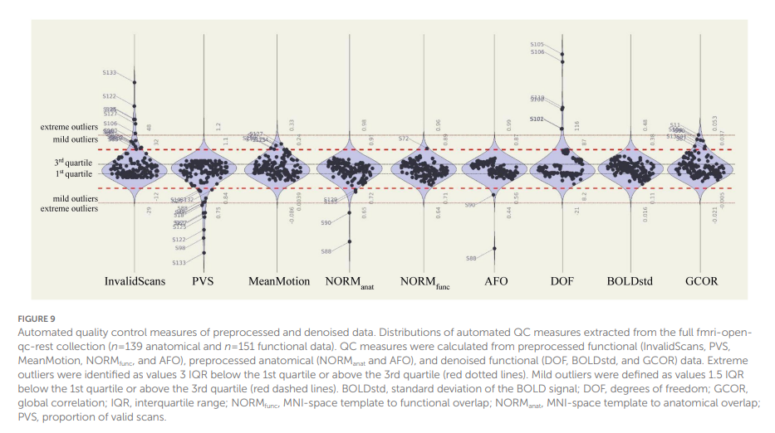

* **Denoising**

In this step ,It’s better to get QA plot, at first.

**QA plots**

Distribution of functional

For example (Morfini et al,2023).

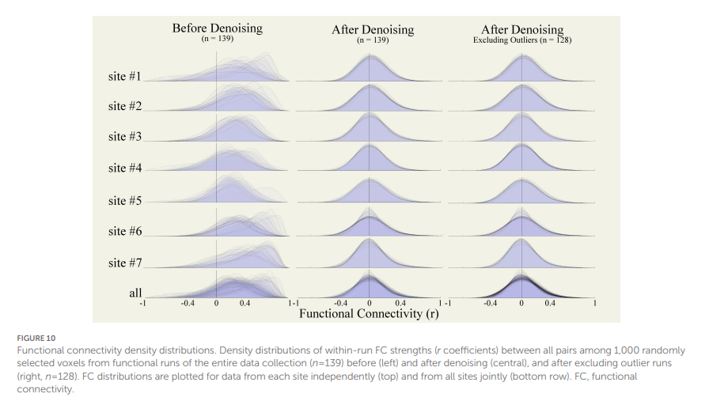

Distribution of QC-FC

For example, Denoising increased the percentage match levels of QC-FC distributions for InvalidScans [average within-site % match = 94.24 ± 2.56 (91.47; 97.68)], MeanMotion [96.82 ± 1.07 (95.64; 98.89)], and PVS [94.21 ± 2.50 (91.47; 97.26)]. After, excluding all runs with identified extreme outliers in any of the evaluated QC measures (n=10, 1 run identified during raw-level visual QC, 2 runs with problems in spatial normalization, and 7 runs with extreme low PVS) increased the percentage match level of QC-FC distributions for InvalidScans [average within-site % match=96.79±2.07 (92.35; 98.48)], MeanMotion [97.64±1.03 (96.12; 99.21)], and PVS [96.75±2.04 (92.35; 98.48)] (Morfini et al,2023).

Check QC-FC % match. If below 95%, consider excluding subjects contributing to this.

Examine the distribution of functional connectivity (FC). Exclude subjects with severely skewed or bimodal distributions.

Review DOF, BOLDstd, and GCOR for outliers. For example, very low DOF indicates over-aggressive denoising**.**

Final Check : After exclusions, ensure QC-FC % meets the 95% threshold. If not, adjust exclusion criteria iteratively.

|  |  |  |
| --- | --- | --- |
| **QC Measure** | **Description** | **Interpretation** |
| **Gschange** | Global signal change timeseries: Scan-to-scan change in global BOLD signal. | Higher values indicate sudden variability in signal intensity. |
| **FD** | Framewise displacement: Maximum change in head position between scans. | Higher values indicate sudden head motion. |
| **Scrubbing** | Timeseries flagging outlier scans (1 for outlier, 0 otherwise). | 1 indicates a scan identified as a potential outlier. |
| **Realignment** | Head motion parameters (translation in mm, rotation in radians). | Higher absolute values indicate larger relative motion. |
| **WM** | Principal components of BOLD signal in white matter. | Higher absolute values indicate larger departures from the average WM signal. |
| **CSF** | Principal components of BOLD signal in cerebrospinal fluid. | Higher absolute values indicate larger departures from the average CSF signal. |
| **MaxMotion** | Maximum framewise displacement in a run. | Higher values indicate extreme motion spikes. |
| **InvalidScans** | Number of scans flagged as outliers. | Higher values indicate more outlier scans. |
| **ValidScans** | Number of valid (non-outlier) scans. | Lower values indicate fewer surviving scans. |
| **PVS** | Proportion of valid scans (ValidScans / TotalScans). | Lower values indicate a higher presence of outlier scans. |
| **MeanGSchange** | Mean global signal change across valid scans. | Higher values indicate residual variability in the global signal after scrubbing. |
| **MeanMotion** | Mean framewise displacement across valid scans. | Higher values indicate residual motion after scrubbing. |
| **NORMfunc** | Dice similarity coefficient between functional data and MNI gray matter mask. | Lower values indicate worse normalization of functional data. |
| **NORManat** | Dice similarity coefficient between anatomical data and MNI gray matter mask. | Lower values indicate worse normalization of anatomical data. |
| **AFO** | Dice similarity coefficient between anatomical and functional gray matter masks. | Lower values indicate worse inter-modality coregistration. |
| **tissue_vol** | Volume of gray matter, white matter, or cerebrospinal fluid. | Extreme values indicate anatomical differences or normalization issues. |
| **tissue_eroded_vol** | Volume of tissue after 1-voxel erosion. | Extreme values indicate anatomical differences or normalization issues. |
| **DOF** | Effective degrees of freedom after denoising. | Lower values indicate overly aggressive denoising, leading to loss of variability. |
| **BOLDstd** | Standard deviation of the BOLD signal after denoising. | High values may indicate residual noise; low values may indicate loss of signal. |
| **GCOR** | Mean global correlation between all voxels. | High absolute values may indicate residual noise or overly aggressive denoising. |
| **QC-FC %** | Percentage match level of QC-FC correlations. | Values above 95% indicate negligible noise effects on functional connectivity. |

References

Andy's Brain Book (Jahn, 2022. doi:10.5281/zenodo. 5879293)

Morfini F, Whitfield-Gabrieli S and Nieto-Castañón A (2023) Functional connectivity MRI quality control procedures in CONN. Front. Neurosci. 17:1092125. doi: 10.3389/fnins.2023.1092125

https://youtu.be/c4F06zlfXT4?si=_M83QThdt99hb2EM

https://youtu.be/ro3nk_RegDU?si=lPVfoiC5sWNNSyzH

<https://youtu.be/eHSsUzUSwf0?si=xDHHRaoQ3VwPFh9>e

<https://youtu.be/2CeZ7EYHRpk?si=yoTTXLJpVacLKZ0P>

Author: Armineh Oloumi

Email: armineolumi@gmail.com